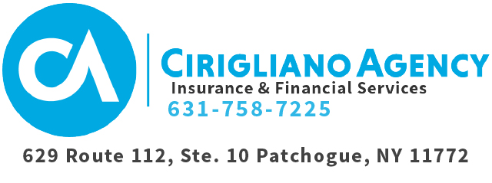
Financial Planning Form
Date Completed:

This document is strictly confidential. Your information will be not be shared.

Client Name: |  | M | F | Date of Birth:

Citizenship: |  | SS #:

Driver’s License State: |  | Driver’s License ID #:

Driver’s License Issued Date: |  | Driver’s License Expiration Date:

Home Address:

How long have you lived at this address? |  | Do You: | Own | Rent

Cell Phone: |  | Email:

Height: |  | Weight: |  | Primary Doctor:

Do you smoke? | Yes | No | Do you take prescription medications? | Yes | No

If yes, please list medications.

Spouse Name: |  | M | F | Date of Birth:

Citizenship: |  | SS #:

Driver’s License State: |  | Driver’s License ID #:

Driver’s License Issued Date: |  | Driver’s License Expiration Date:

Cell Phone: |  | Email:

Height: |  | Weight: |  | Primary Doctor:

Does your spouse smoke? | Yes | No | Does your spouse take prescription medications? | Yes | No

If yes, please list medications.

OCCUPATION

Client Job Title: |  | Employer:

Street Address: |  | City: |  | State: |  | Zip:

Phone Number: |  | # of Years Employed: |  | Income:

Spouse Job Title: |  | Employer:

Street Address: |  | City: |  | State: |  | Zip:

Phone Number: |  | # of Years Employed: |  | Income:

DEPENDENTS

Do you have any children? | Yes | No | If yes, how many?

Child’s Name: |  | M | F | Date of Birth:
Occupation:

Child’s Name: |  | M | F | Date of Birth:
Occupation:

Child’s Name: |  | M | F | Date of Birth:
Occupation:

Child’s Name: |  | M | F | Date of Birth:
Occupation:

Child’s Name: |  | M | F | Date of Birth:
Occupation:

How do you feel about saving for children’s college education?

Have you implemented any kind of savings plans yet? | Yes | No

RESIDENCE

VALUE | REMAINING MORTGAGE | INTEREST RATE | YEARS LEFT

INSURANCE

INSURED | COMPANY | POLICY # | YEAR ISSUED | TYPE | FACE AMT | ANNUAL PREMIUM | CURRENT CASH VALUE

Do you have any long-term care insurance policies? | Yes | No

If yes, please specify:

Do you have any special interests or health conditions that could affect your insurance planning? | Yes | No

If yes, please specify: | Client

Spouse

LIABILITIES

 | MONTHLY |  | ANNUALLY
Mortgage
Utilities
Cable
Home Phone
Cell Phone
Food
Car Payments
Car Insurance
Life Insurance
529 Plan
Credit Cards
Entertainment
Monthly Dues / Membership Fees
TOTAL EXPENSES
TOTAL TAXES

Is there any income from other sources? | Yes | No | Source:

Attorney: |  | Phone #:

Accountant: |  | Phone #:

ASSETS

Do you own any of the following?

TYPE | VALUE |  | OWNED BY |  | FINANCIAL INSTITUTION
Savings
Checking
CD
T Bills
Tax-free Bond Funds
Income Funds
IRAs
401K
Pension
Credit Unions
Stocks
Mutual Funds

What are your investment goals?

Are you happy with your rate of return? | Yes | No

THANK YOU.

